Story

Date | 25 July 2026
Project Name | Global Ai in Education
Maximum Marks | 5 Marks

Activity 1: Story Design
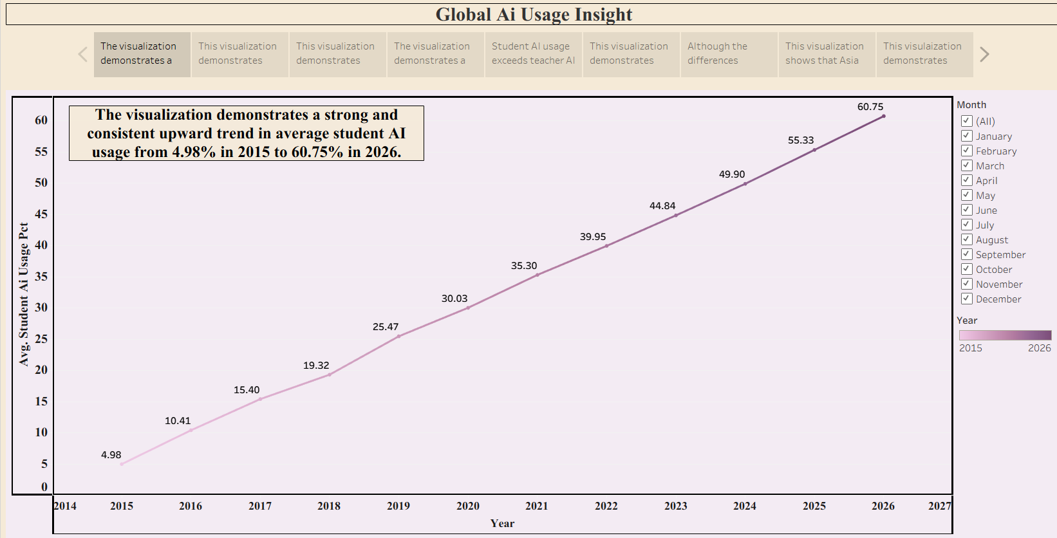

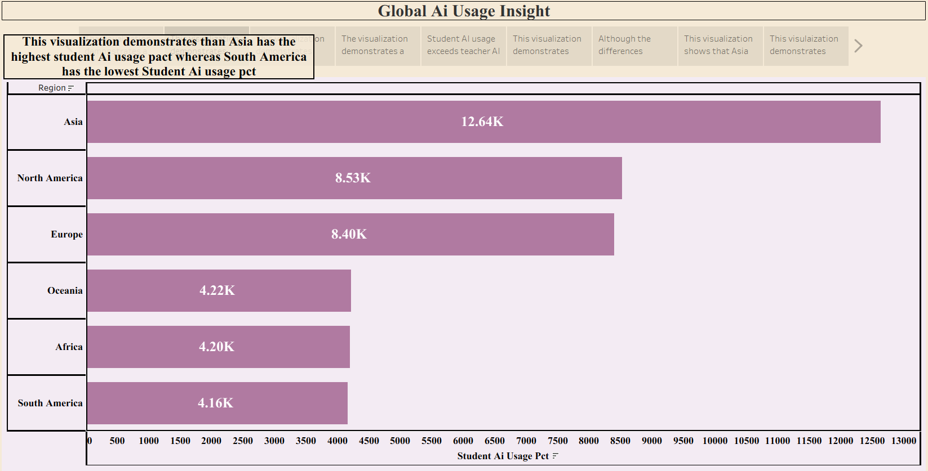

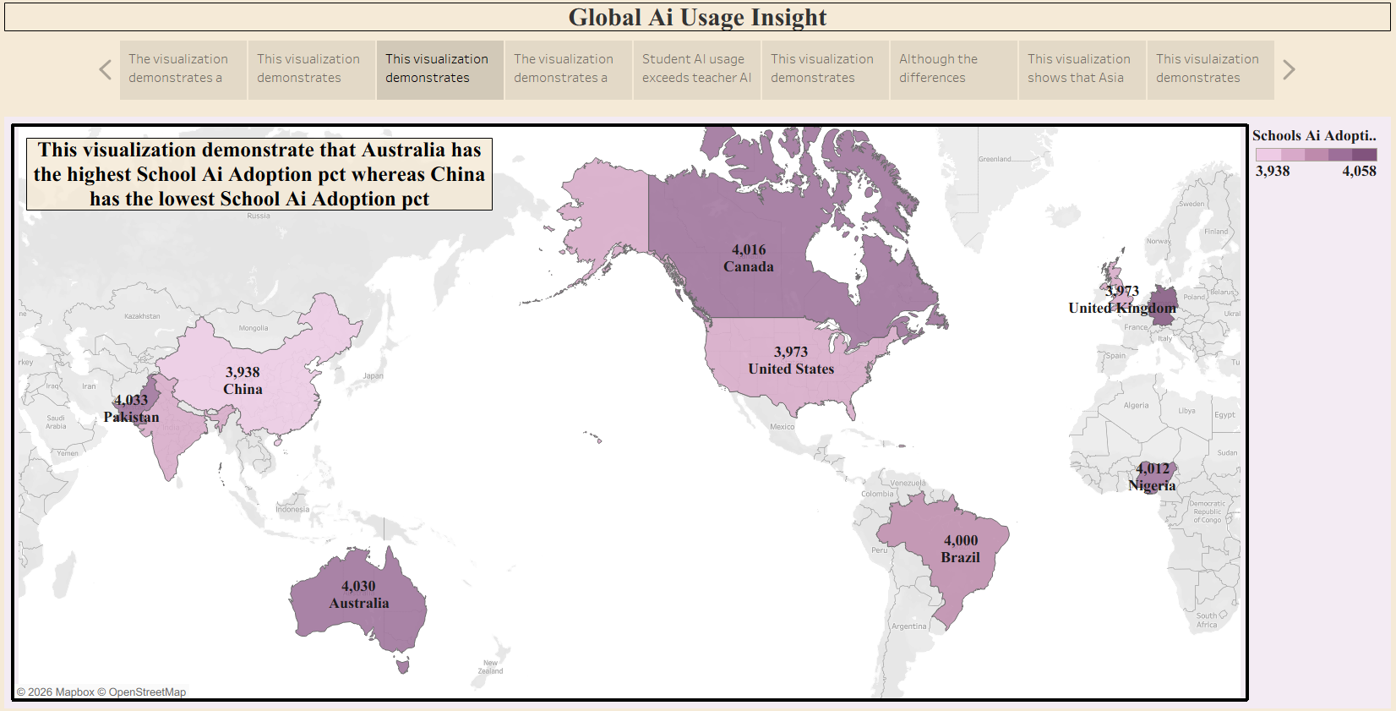

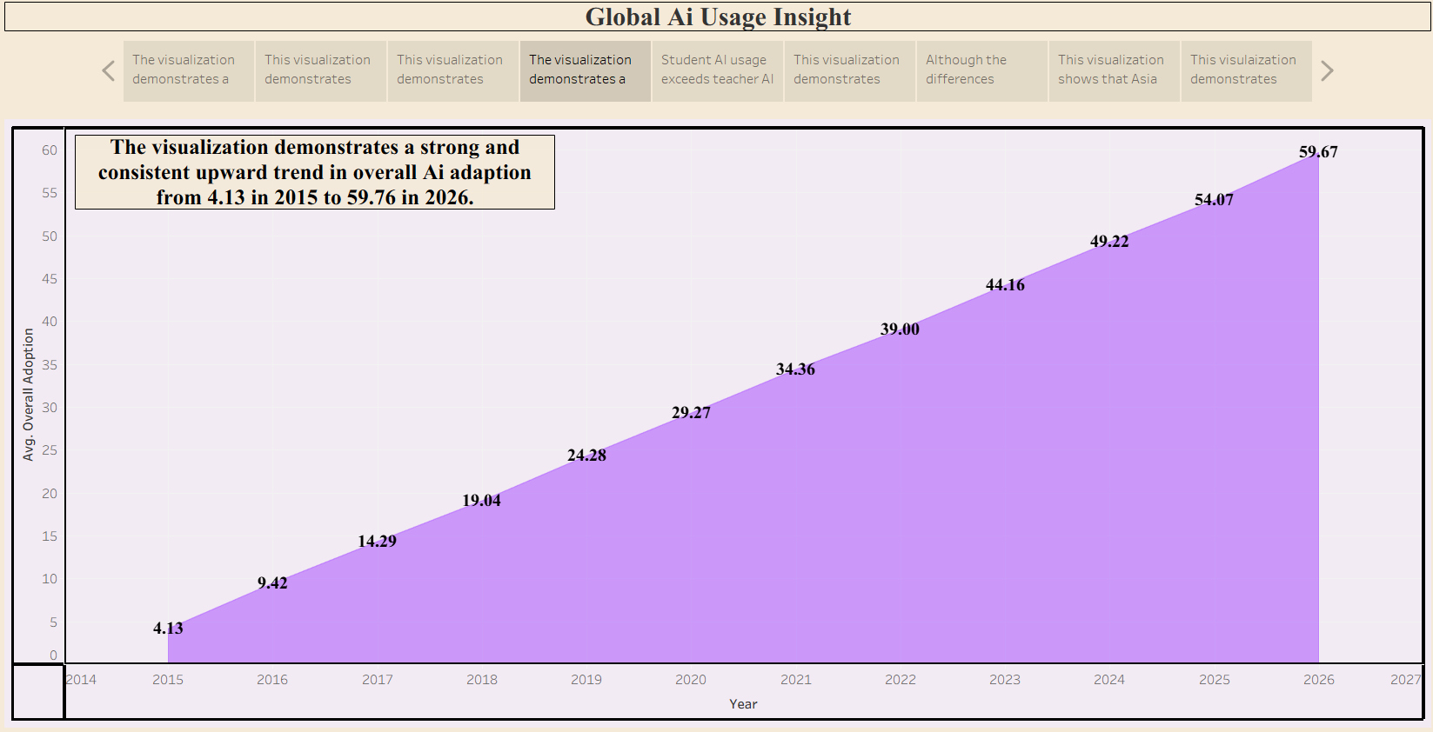

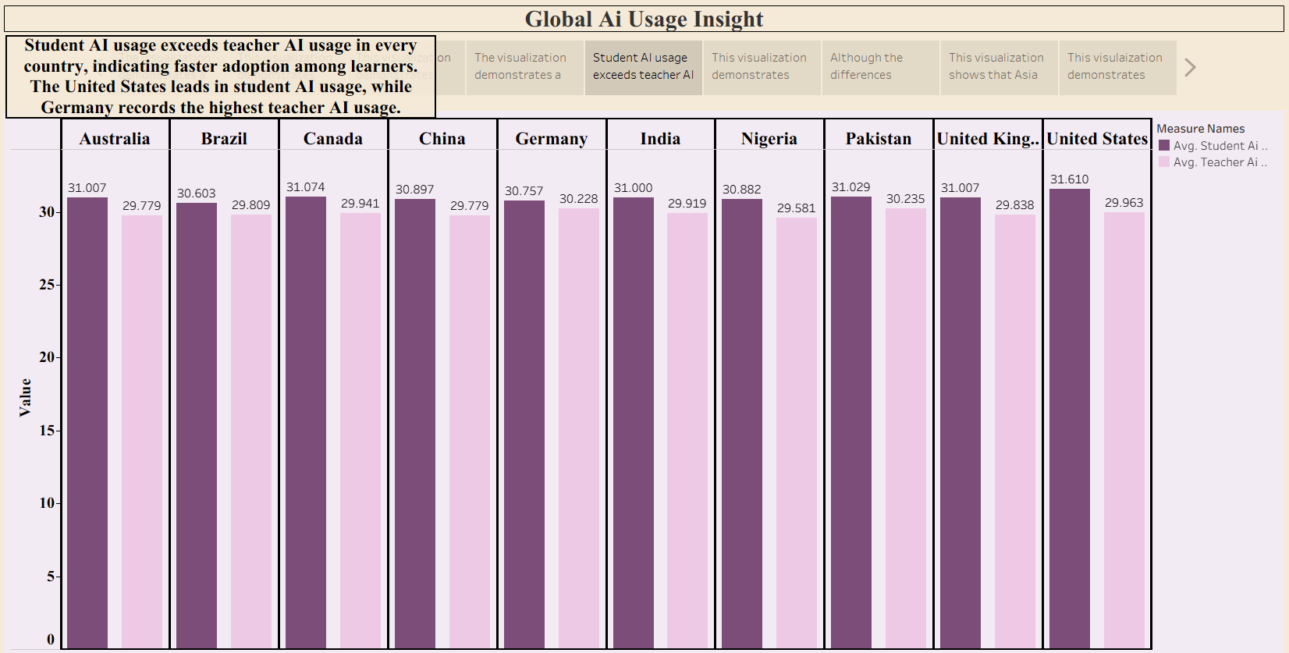

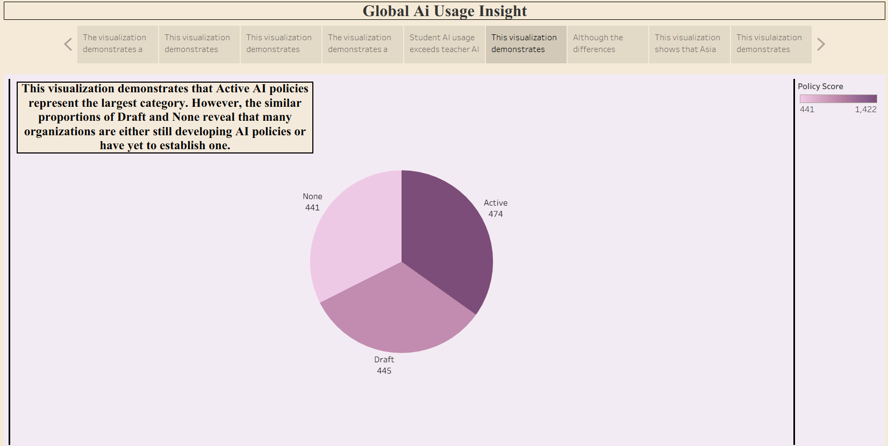

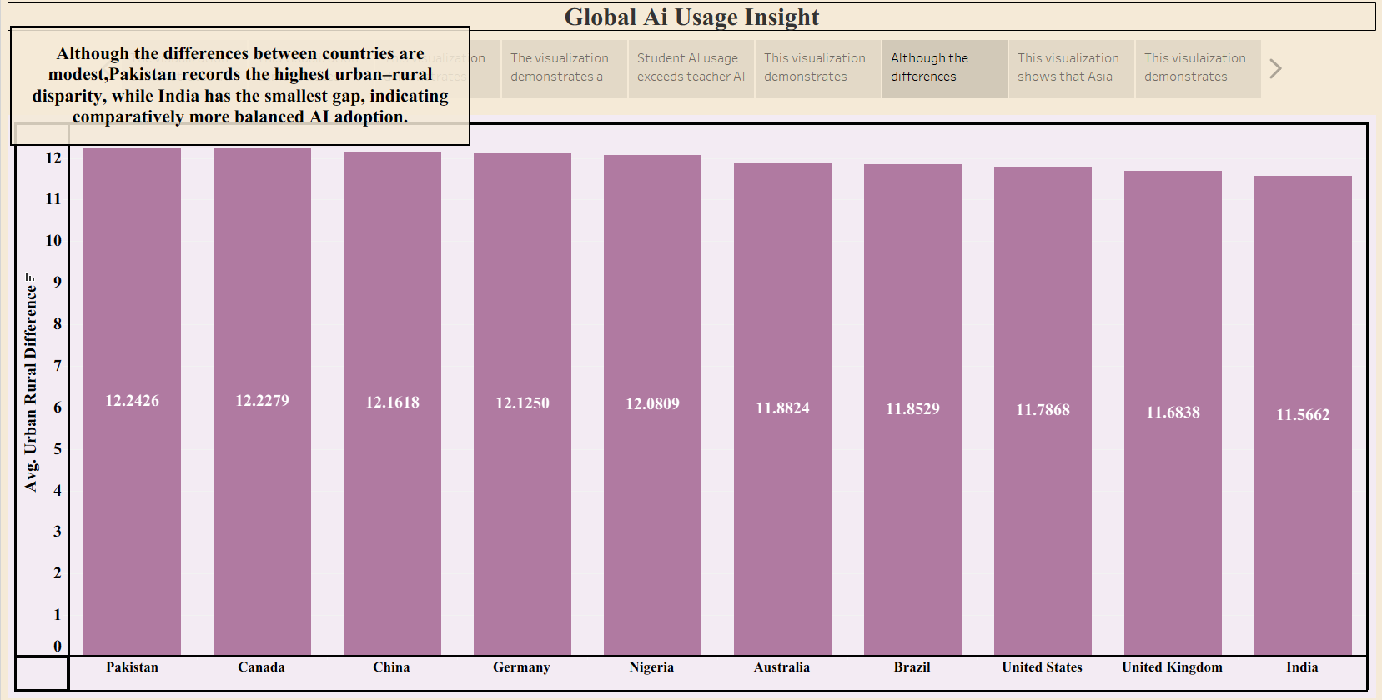

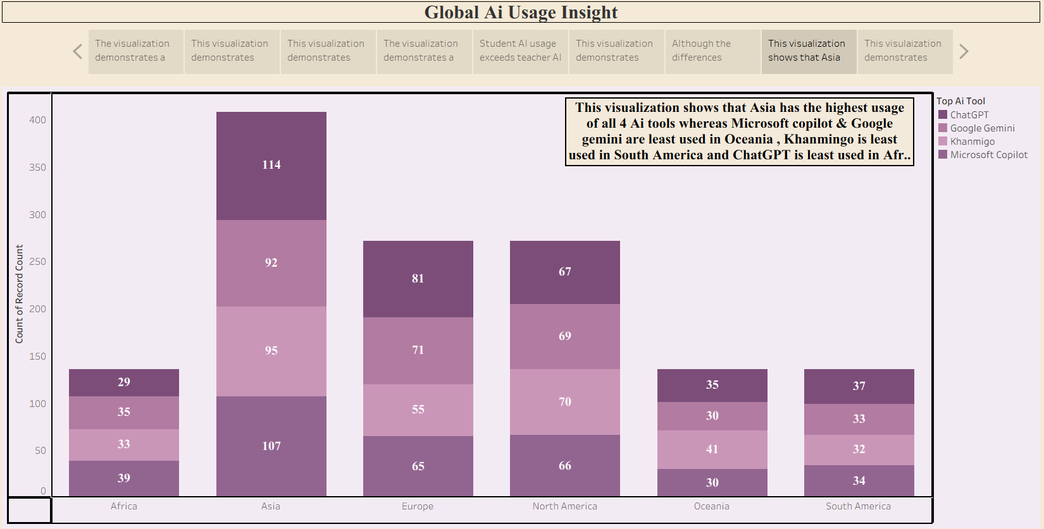

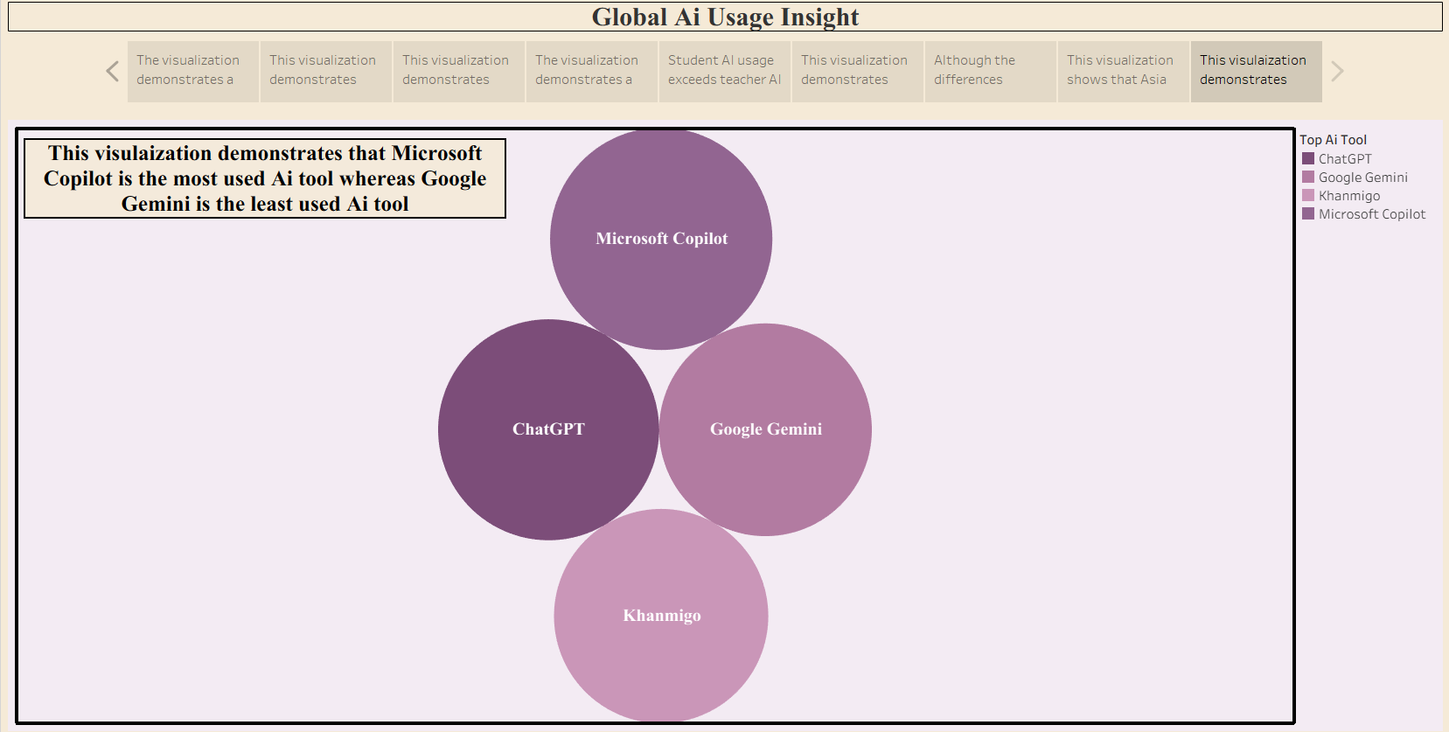

Story Observations

Observation 1: AI Adoption is Increasing Consistently
The analysis shows a steady year-on-year increase in AI adoption from 2015 to 2026. Both the AI adoption growth chart and student usage trend indicate that educational institutions are increasingly integrating AI technologies into teaching and learning.

Observation 2: Student AI Usage Exceeds Teacher AI Usage
Across most countries, students demonstrate slightly higher AI usage than teachers. This suggests that students are adopting AI tools more rapidly, while teachers may require additional training and institutional support to effectively integrate AI into classrooms.

Observation 3: Asia Leads in AI Usage
Among all regions, Asia records the highest student AI usage, followed by North America and Europe. This indicates stronger digital transformation and greater acceptance of AI-powered educational technologies within Asian educational institutions.

Observation 4: Urban Areas Have Higher AI Adoption
The Urban-Rural comparison reveals that urban populations consistently exhibit higher AI usage than rural populations. This highlights the continuing digital divide and emphasizes the need for improved infrastructure and AI accessibility in rural regions.

Observation 5: AI Adoption is Growing Worldwide
The world map demonstrates that AI adoption is not limited to a single region but is expanding globally. Several countries show high school AI adoption levels, indicating worldwide acceptance of AI in education.

Observation 6: Government Policies Influence AI Adoption
The Government AI Policy Distribution chart shows that many countries have active or draft AI policies, while some still lack formal AI regulations. Stronger policy support is likely to accelerate responsible AI implementation in educational institutions.

Observation 7: AI Tool Preferences Differ Across Regions
Regional analysis indicates that different geographical regions prefer different AI tools. However, ChatGPT and Google Gemini appear among the most widely adopted platforms, reflecting their broad applicability in education.

Observation 8: AI Usage Continues to Rise Every Year
Both AI adoption and student usage trends exhibit continuous growth with no significant decline across the observed years. This suggests sustained investment in AI technologies and increasing confidence in AI-assisted learning.

Activity 2:
Publish Story on Tableau Public and Paste Public link below:
https://public.tableau.com/app/profile/akshita.bhadauria/vizzes

